7.12: Tarzan is lower than his original height by a distance 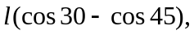 so his speed is
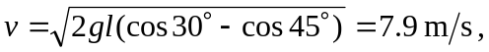
a bit quick for conversation.

